## DAY-3 EXPERIMENT

**1. ADD TWO NUMBERS**

|  |
| --- |
| #include <stdio.h> |
|  | int main() |
|  | { |
|  | int first, second, *p, *q, sum; |
|  |  |
|  | printf("Enter two integers to add\n"); |
|  | scanf("%d%d", &first, &second); |
|  |  |
|  | p = &first; |
|  | q = &second; |
|  |  |
|  | sum = *p + *q; |
|  |  |
|  | printf("Sum of the numbers = %d\n", sum); |
|  |  |
|  | return 0; |
|  | } |

Out put:

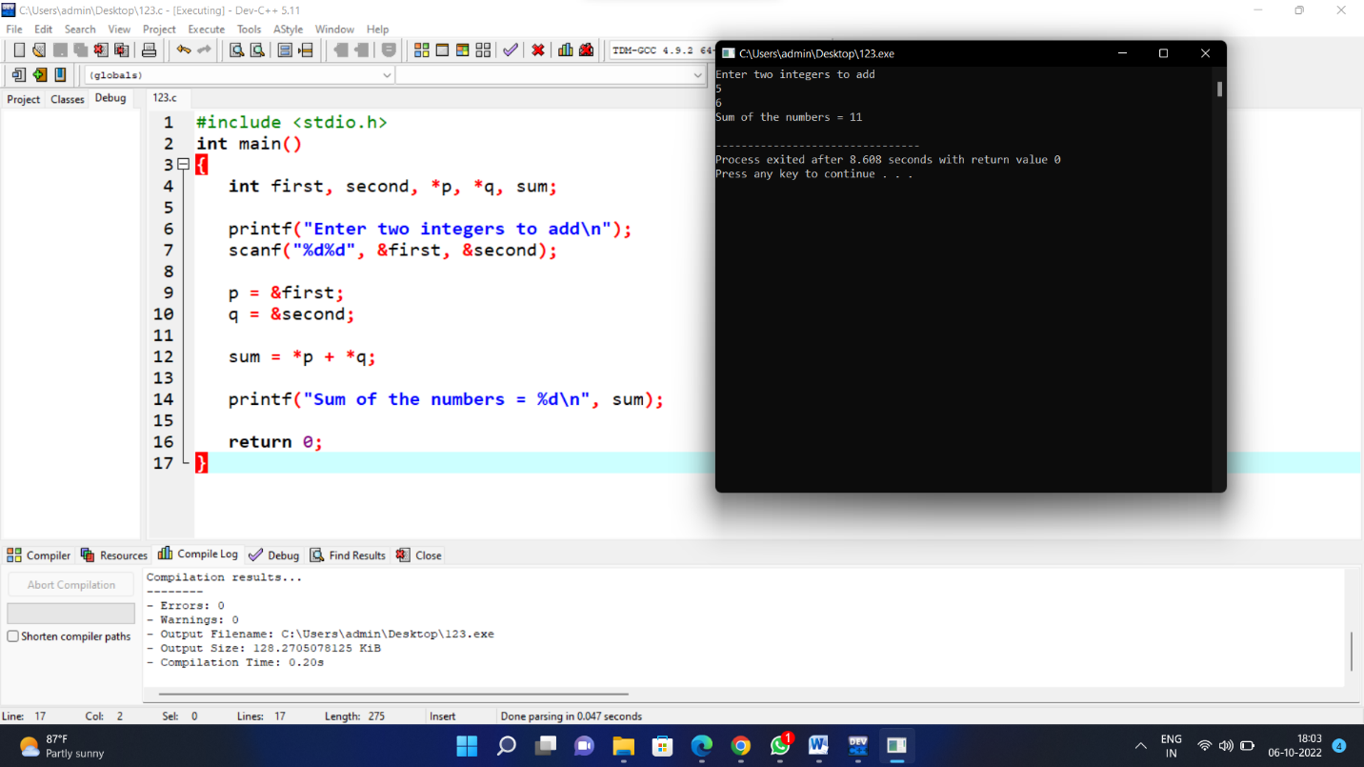

## ****2.MAXIMUM NUMBER****

|  |
| --- |
| #include<stdio.h> |
|  | #include<conio.h> |
|  | int main() |
|  | { |
|  | int x,y, *large, *xptr,*yptr; |
|  |  |
|  | printf("Enter the value of x and y :"); |
|  | scanf("%d%d",&x,&y); |
|  | xptr=&x; |
|  | yptr=&y; |
|  | if(*xptr>*yptr) |
|  | large=xptr; |
|  | else |
|  | large=yptr; |
|  | printf("The MAXIMUM nmuber is : %d",*large); |
|  | getch(); |
|  | } |

Output:-

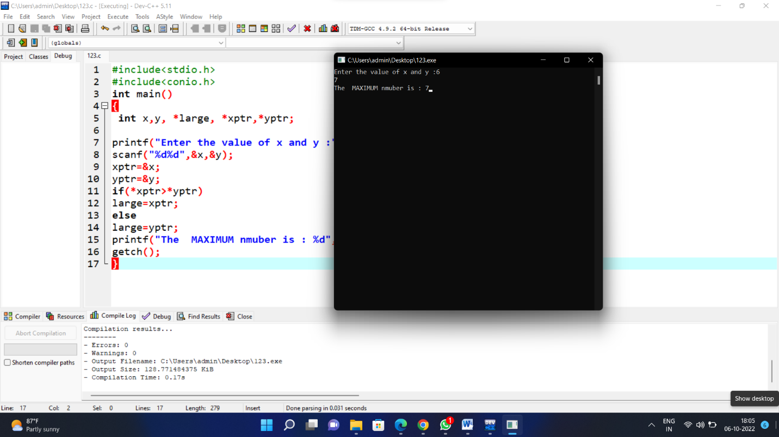

## ****3.LARGEST ELEMENT****

|  |
| --- |
|  |
| #include <stdio.h> |
|  | #include <stdlib.h> |
|  | int main() |
|  | { |
|  | int i,n; |
|  | float *element; |
|  | printf("\n\n Pointer : Find the largest element using Dynamic Memory Allocation :\n"); |
|  | printf("-------------------------------------------------------------------------\n"); |
|  | printf(" Input total number of elements(1 to 100): "); |
|  | scanf("%d",&n); |
|  | element=(float*)calloc(n,sizeof(float)); |
|  | if(element==NULL) |
|  | { |
|  | printf(" No memory is allocated."); |
|  | exit(0); |
|  | } |
|  | printf("\n"); |
|  | for(i=0;i<n;++i) |
|  | { |
|  | printf(" Number %d: ",i+1); |
|  | scanf("%f",element+i); |
|  | } |
|  | for(i=1;i<n;++i) |
|  | { |
|  | if(*element<*(element+i)) |
|  | *element=*(element+i); |
|  | } |
|  | printf(" The Largest element is : %.2f \n\n",*element); |
|  | return 0; |
|  | } |
|  |  |

Output:-

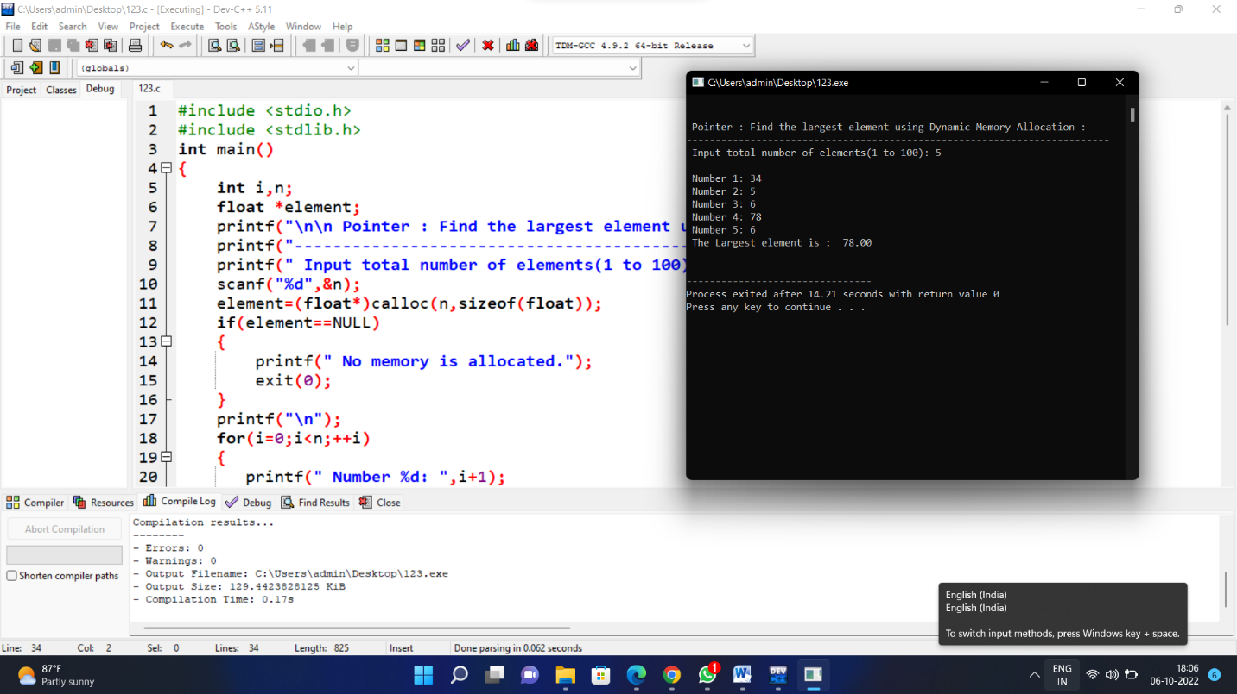

## ****4. LENGTH OF STRING****

|  |
| --- |
| #include<stdio.h> |
|  | #include<conio.h> |
|  |  |
|  | int string_ln(char*); |
|  |  |
|  | int main() { |
|  | char str[20]; |
|  | int length; |
|  |  |
|  | printf("\nEnter any string : "); |
|  | gets(str); |
|  |  |
|  | length = string_ln(str); |
|  | printf("The length of the given string %s is : %d", str, length); |
|  | getch(); |
|  | } |
|  |  |
|  | int string_ln(char*p) |
|  | { |
|  | int count = 0; |
|  | while (*p != '\0') { |
|  | count++; |
|  | p++; |
|  | } |
|  | return count; |
|  | } |

Output:-

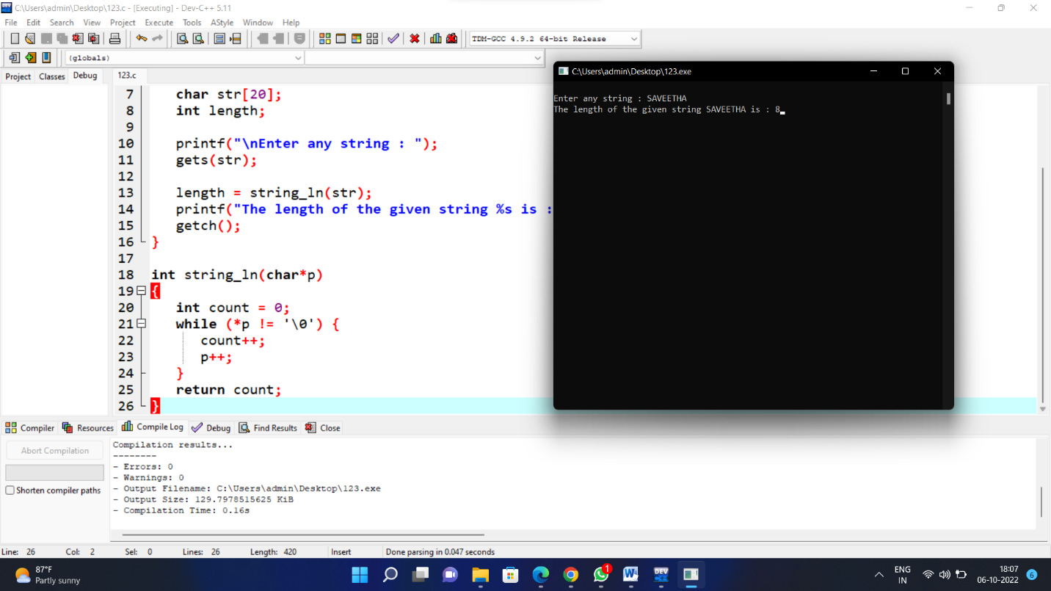

**5. ADD WITH CALL BY REFERENCE**

|  |  |
| --- | --- |
|  | #include <stdio.h> |
|  | long addTwoNumbers(long *, long *); |
|  |  |
|  | int main() |
|  | { |
|  | long fno, sno, sum; |
|  |  |
|  | printf("\n\n Pointer : Add two numbers using call by reference:\n"); |
|  | printf("-------------------------------------------------------\n"); |
|  |  |
|  | printf(" Input the first number : "); |
|  | scanf("%ld", &fno); |
|  | printf(" Input the second number : "); |
|  | scanf("%ld", &sno); |
|  | sum = addTwoNumbers(&fno, &sno); |
|  | printf(" The sum of %ld and %ld is %ld\n\n", fno, sno, sum); |
|  | return 0; |
|  | } |
|  | long addTwoNumbers(long *n1, long *n2) |
|  | { |
|  | long sum; |
|  | sum = *n1 + *n2; |
|  | return sum; |
|  | } |

Output:-

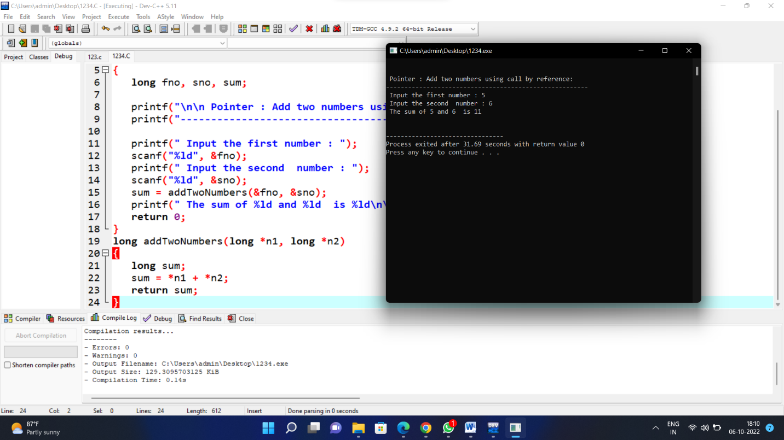

**6. STORE AND RETRIEVE IN ARRAY**

|  |  |
| --- | --- |
|  | #include <stdio.h> |
|  | int main() |
|  | { |
|  | int arr1[25], i,n; |
|  | printf("\n\n Pointer : Store and retrieve elements from an array :\n"); |
|  | printf("------------------------------------------------------------\n"); |
|  | printf(" Input the number of elements to store in the array :"); |
|  | scanf("%d",&n); |
|  |  |
|  | printf(" Input %d number of elements in the array :\n",n); |
|  | for(i=0;i<n;i++) |
|  | { |
|  | printf(" element - %d : ",i); |
|  | scanf("%d",arr1+i); |
|  | } |
|  | printf(" The elements you entered are : \n"); |
|  | for(i=0;i<n;i++) |
|  | { |
|  | printf(" element - %d : %d \n",i,*(arr1+i)); |
|  | } |
|  | return 0; |
|  | }  Output:-  image  **7. SWAPPING**   |  |  | | --- | --- | |  | #include <stdio.h> | |  | void swapNumbers(int *x,int *y,int *z); | |  | int main() | |  | { | |  | int e1,e2,e3; | |  | printf("\n\n Pointer : Swap elements using call by reference :\n"); | |  | printf("------------------------------------------------------\n"); | |  | printf(" Input the value of 1st element : "); | |  | scanf("%d",&e1); | |  | printf(" Input the value of 2nd element : "); | |  | scanf("%d",&e2); | |  | printf(" Input the value of 3rd element : "); | |  | scanf("%d",&e3); | |  |  | |  |  | |  | printf("\n The value before swapping are :\n"); | |  | printf(" element 1 = %d\n element 2 = %d\n element 3 = %d\n",e1,e2,e3); | |  | swapNumbers(&e1,&e2,&e3); | |  | printf("\n The value after swapping are :\n"); | |  | printf(" element 1 = %d\n element 2 = %d\n element 3 = %d\n\n",e1,e2,e3); | |  | return 0; | |  | } | |  | void swapNumbers(int *x,int *y,int *z) | |  | { | |  | int tmp; | |  | tmp=*y; | |  | *y=*x; | |  | *x=*z; | |  | *z=tmp; | |  | } | |

Output:-

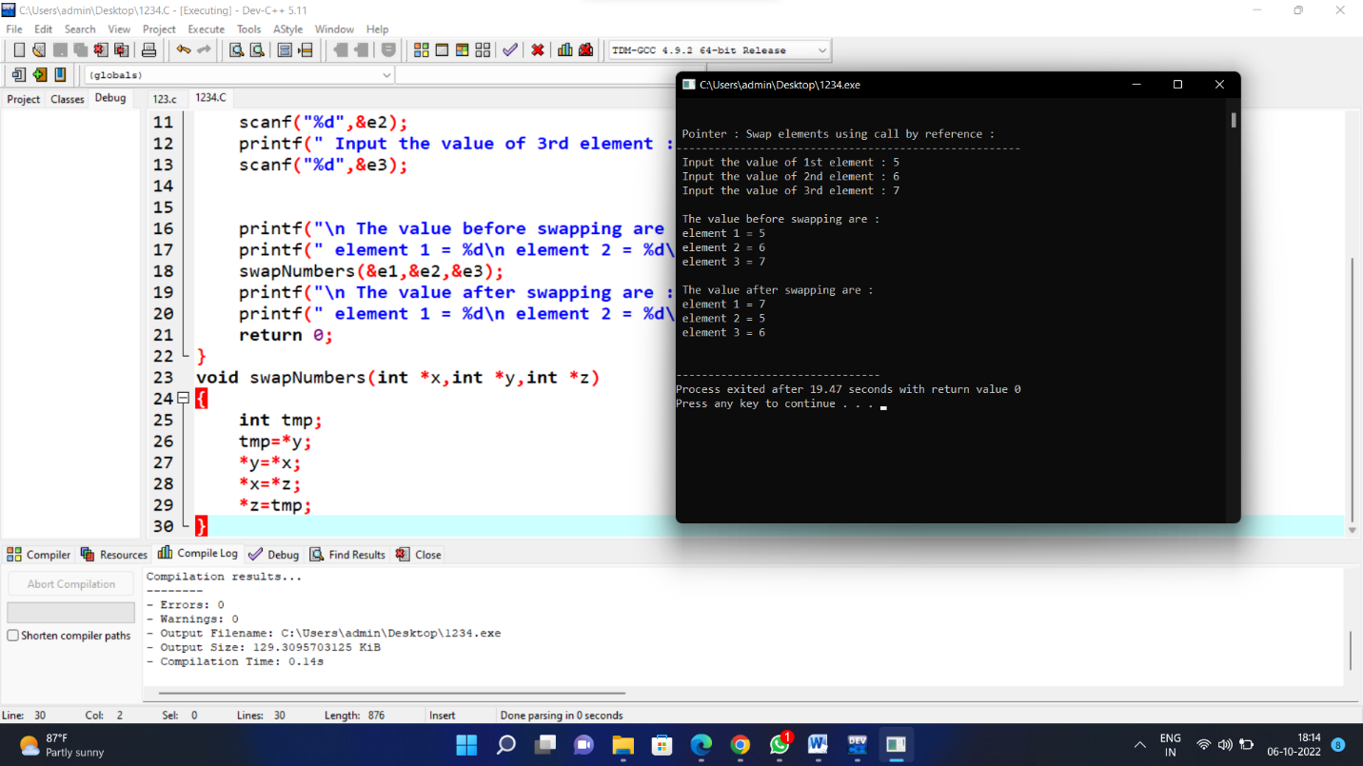

**8.FACTORIAL USING POINTERS**

|  |  |
| --- | --- |
|  | # include<stdio.h> |
|  | int main( ) |
|  | { |
|  | int num, fact=1 ; |
|  | int *pn, *pf ; |
|  | printf(" Enter any Number : ") ; |
|  | scanf("%d ",& num) ; |
|  |  |
|  | pn = & num ; |
|  | pf = & fact ; |
|  |  |
|  | do |
|  | { |
|  | *pf = ( *pf ) * ( *pn ) ; |
|  | *pn = *pn - 1 ; |
|  | }while( *pn > 0) ; |
|  | printf("\n Factorial of entred number is : %d ",*pf) ; |
|  | return ( 0 ); |
|  | }  Output:-  image  **9.STUDENT GRADE**   |  |  | | --- | --- | |  | #include<stdio.h> | |  | void main() | |  | { | |  | int marks; | |  | printf("Enter your marks "); | |  | scanf("%d",&marks); | |  | if(marks<0 || marks>100) | |  | { | |  | printf("Wrong Entry"); | |  | } | |  | else if(marks<50) | |  | { | |  | printf("Grade F"); | |  | } | |  | else if(marks>=50 && marks<60) | |  | { | |  | printf("Grade D"); | |  | } | |  | else if(marks>=60 && marks<70) | |  | { | |  | printf("Grade C"); | |  | } | |  | else if(marks>=70 && marks<80) | |  | { | |  | printf("Grade B"); | |  | } | |  | else if(marks>=80 && marks<90) | |  | { | |  | printf("Grade A"); | |  | } | |  | else | |  | { | |  | printf("Grade A+"); | |  | } | |  | }  Output:-  image  **10.MAXIMUM AND MINIMUM**   |  |  | | --- | --- | |  | #include <stdio.h> | |  | #include <conio.h> | |  |  | |  |  | |  | int main() | |  | { | |  | int a[1000],i,n,min,max; | |  |  | |  | printf("Enter size of the array : "); | |  | scanf("%d",&n); | |  |  | |  | printf("Enter elements in array : "); | |  | for(i=0; i<n; i++) | |  | { | |  | scanf("%d",&a[i]); | |  | } | |  |  | |  | min=max=a[0]; | |  | for(i=1; i<n; i++) | |  | { | |  | if(min>a[i]) | |  | min=a[i]; | |  | if(max<a[i]) | |  | max=a[i]; | |  | } | |  | printf("minimum of array is : %d",min); | |  | printf("\nmaximum of array is : %d",max); | |  |  | |  |  | |  | return 0; | |  | } | | |

Output:-

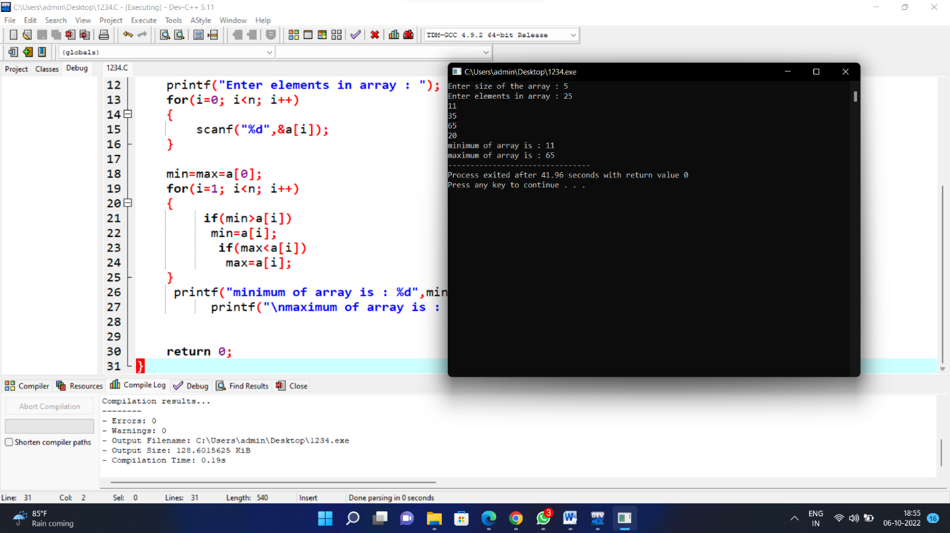

**11.EMPLOYEE BONUS**

|  |  |
| --- | --- |
|  | #include<stdio.h> |
|  | int main() |
|  | { |
|  | float sal,bon,pay,ad; |
|  | char gd; |
|  |  |
|  | printf("enter the salary:"); |
|  | scanf("%f",&sal ); |
|  |  |
|  |  |
|  |  |
|  | printf("enter the grade:"); |
|  | scanf("%d",&gd); |
|  | if(gd =='A'){ |
|  | bon=sal*0.05; |
|  |  |
|  | } |
|  |  |
|  | else{ |
|  |  |
|  | bon=sal*0.1; |
|  |  |
|  | } |
|  |  |
|  | printf("%f the bonus is: ",bon); |
|  | if(sal<10000) |
|  | { |
|  | bon=bon*0.2; |
|  | } |
|  | else{ |
|  |  |
|  | pay=sal+bon; |
|  | printf("the total amount to pay: %f",pay); |
|  | return 0; |
|  |  |
|  |  |
|  | }} |

Output:-

